REPORT FOR: | CABINET
Date: | 12 December 2013
Subject: | Collection Fund 2013-2014
Key Decision: | Yes
Responsible Officer: | Simon George, Director of Finance and Assurance
Portfolio Holder: | Councillor Tony Ferrari, Portfolio Holder for Finance
Exempt: | No
Decision subject to Call-in: | Yes
Enclosures: | Nil

Section 1 – Summary and Recommendations

This report sets out the estimated financial position on the Collection Fund as at 31 March 2014 and how it is shared amongst the constituent precepting bodies and Central Government.

Recommendations
Cabinet is asked to:
- Note an estimated surplus of £2,095,937 on the Collection Fund as at 31 March 2014 of which £1,676,274 is the Harrow share; and
- Agree that an amount of £1,676,274 be transferred to the General Fund in 2014-15.

Reason (for recommendation)
To report to Cabinet on the Council’s statutory obligation to make an estimate of the surplus or deficit on the Collection Fund by 15 January 2014. Approval to the recommendations set out is a major part of the annual budget review process.

Section 2 – Report

Executive Summary

- The Collection Fund account reflects the statutory requirements for the Council to maintain a separate Fund, in relation to the operation of the Business Rates Retention Scheme (BRRS) and Council Tax. The Fund records all the transactions for billing in respect of Non Domestic Rates (NDR) and Council tax, exemptions and discounts granted, provision for bad debts and appeals and payments to the precept authorities Greater London Authority (GLA), Council’s own demand and Central Government.

- At the end of each year the surplus/deficit on the Fund is subsequently borne by, or distributed to, the billing authority (i.e. Harrow), the preceptor (i.e. GLA) and Central Government. The estimated financial position on the Collection Fund as at 31 March 2014 and the share of surplus for each stakeholders are summarised below:-

 | Council Tax (Table 1a) |  | BRRS  (Table 2a) |  | Total
 | % | £m | % | £m | £m
Harrow Council | 79.977 | 1.676 | 30.000 | 0 | 1.676
Greater London Authority | 20.023 | 0.420 | 20.000 | 0 | 0.420
Central Government |  |  | 50.000 | 0 | 0
 |  | 2.096 |  | 0 | 2.096

Council Tax
- There are mainly four factors in the calculation of the estimated surplus/deficit on Council Tax:-
  - Surplus or deficit brought forward from the previous financial year;
  - Change in the gross income;
  - Change in the expenditure in relation to discounts, exemptions and Local Council Tax Support Scheme; and
- Increase or Decrease in the level of bad debt provision (BDP).

Table 1a
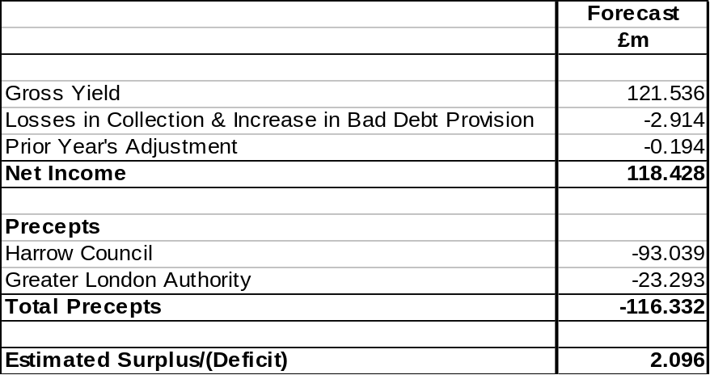

- The collection rate for 2013-14 is slightly below profile resulting mainly from the Council Tax Support Scheme (CTSS) which has impacted approximately 12,000 working age people who have previously not had to pay council tax or received a reduction have now been asked to pay towards their council tax bill. The arrears position for these debts is being monitored and recovery processes are in place to ensure compliance with payment plans. The table below summarises the total arrears position as at 30th November 2013 along with the provision requirement.

Table 1b
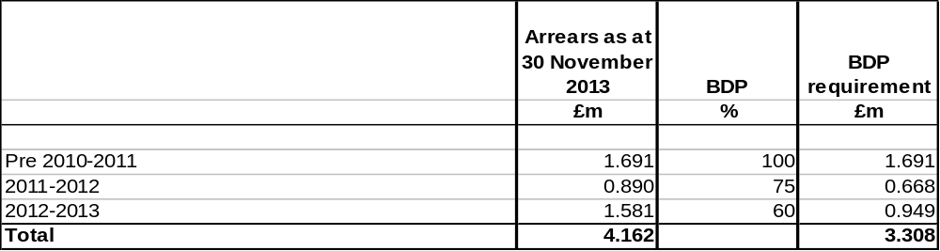
Business Rates Retention Scheme
- In previous years business rates were collected by the local authority and paid into the National Non Domestic Rating Pool. The Authority received an NNDR grant as part of the Revenue support settlement process. From the 1st April 2013 the BRRS was introduced as part of the move to localise and stimulate business growth at a local level. Under the BRRS the Authority pays 50% of its business rates income to Central government, 20% to GLA and retains the remaining 30%.

- There are mainly two factors in the calculation of the estimated surplus/deficit on BRRS:-
  - Change in the gross income; and
- Increase or Decrease in the level of bad debt provision (BDP).

Table 2a
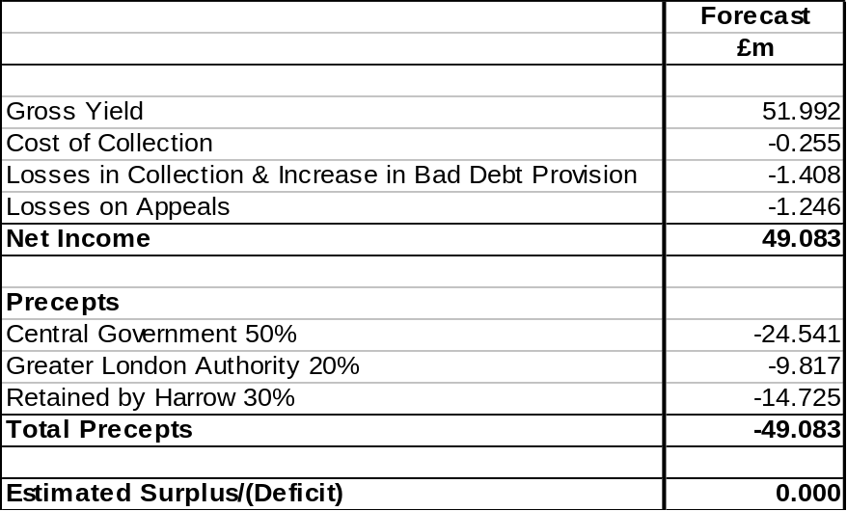

- The table below shows the aged analysis of the debt as at 30 November 2013. The collection rate is slightly below the profile as the Council’s predominant ratepayers are Small Medium Enterprises (SME), who are still being affected by the economic climate which is having an impact on their ability to pay. Although recovery action is taking place, longer time is being given to tax payers to clear the debt which in turn will support small businesses.

Table 2b

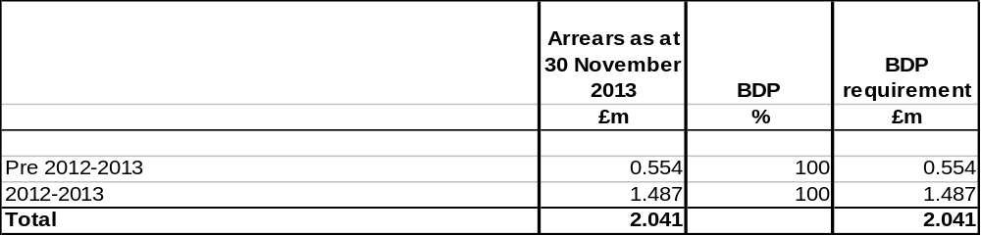
Legal Implications
- Section 50 of the Local Government Finance Act 1992 requires this calculation to be completed as part of the budget setting process.

Financial Implications
- Financial matters are integral to the report.

Performance Issues
- There are risks in achieving the collection target due to economic climate and the new Council Tax Support Scheme. Performance data is shown in the separate reports on Calculation of Council Tax Base for 2014 – 2015 and Calculation of Business Rates Income for 2014 – 2015 on the Cabinet agenda.

Environmental Impact
- There are none directly related to this report.

Risk Management Implications
- In the current economic climate there is a risk that the Council’s collection performance could decline. This would have an adverse impact on the Collection Fund financial position.
- Risk included on Directorate risk register? Yes
- Separate risk register in place? No

Equalities Impact
- There are no direct equalities impacts arising from the decisions within this report.

Corporate Priorities
- This report deals with the Collection Fund which is a key part of the budget setting process and therefore helps deliver the Council’s vision and priorities.

Section 3 - Statutory Officer Clearance

Name: Simon George | x |  | Chief Financial Officer
Date: 14 November 2013
Name: Matthew Adams | x |  | on behalf of the
Date: 2 December 2013 |  |  | Monitoring Officer

Section 4 – Performance Officer Clearance

Name: Martin Randall | x |  | on behalf of the
Date: 14 November 2013 |  |  | Divisional Director Strategic Commissioning

Section 5 – Environmental Impact Officer Clearance

Name: Saeed Atlas | x |  | on behalf of the
Date: 15 November 2013 |  |  | Corporate Director of Environment and Enterprise

Section 6 - Contact Details and Background Papers

Contact: Hasina Shah (Head of Technical Finance and Accountancy) hasina.shah@harrow.gov.uk,
Tel: 0208 424 1573

Background Papers:
- The Local Authorities (Funds) (England) Regulations 1992 http://www.legislation.gov.uk/ukpga/1992/14/contents

- The Non-Domestic Rating (Rates Retention) Regulations 2013 http://www.legislation.gov.uk/ukdsi/2013/9780111532959/contents

- Statement of Accounts 2012/13 http://search.harrow.gov.uk/search.aspx?pckid=1809526021&aid=365691&sw=STATEMENT+OF+ACCOUNTS

Call-In Waived by the Chairman of Overview and Scrutiny Committee |  | NOT APPLICABLE  [Call –in applies]

